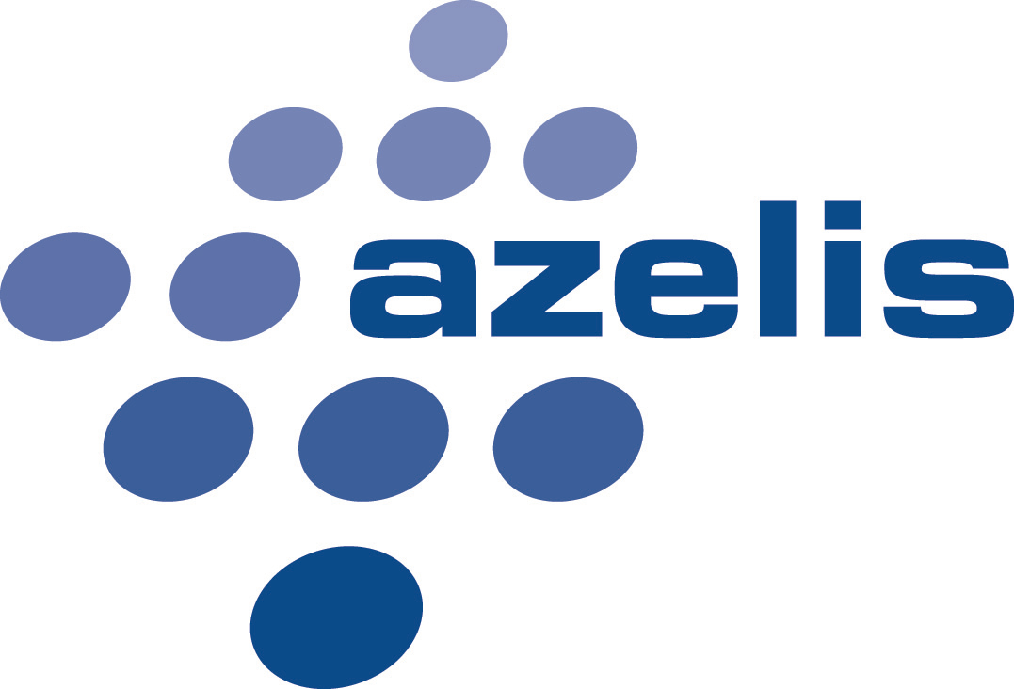

Job Title: Inside Sales Representative Chemicals

Location: Heusden

Company
Azelis is the leading global specialty chemicals distributor providing a diverse range of products and innovative services to more than 40.000 customers in the chemical, coatings, rubber & plastic additives, food & health, animal nutrition, pharma and personal care industries. Through sourcing and distribution channels in every major market around the world, Azelis offers chemical producers market penetration, in-depth local knowledge, value added services and tailored multi-territory solutions.
Azelis employs over 1.700 knowledgeable people in more than 40 countries.
Azelis Benelux NV is an Azelis group company.

Job purpose

As Internal Sales Representative, you will be key in the growth of the Benelux industrial chemicals market by proactively supporting the external sales representative as well as being responsible for your own customer portfolio. Together with the sales manager you will ensure the follow up of important development projects, be responsible for control on networking capital (stock and overdues) and supportive in sales administrative tasks. In this role you will interact and cooperate with customers, suppliers and all company employees, hence good communication skills are essential.

Main Responsibilities

- Support the external sales team, active in a business to business environment to commercialise raw materials and chemical specialties for the industrial chemicals industry;

- Achieve sales targets as defined in the business plan together with the Sales Managers;

- Direct point of contact for customers in the Industrial Chemicals market;

- Support external sales with quarterly price settings and communication back to the customer.

- Follow-up of customers purchasing behavior, detecting opportunities, developing commercial relationships. Follow-up on customer satisfaction;

- Registration and follow-up of complaints;

- Handling of customer requests for samples and technical documents and guarantee close follow-up;

- Follow-up on customer payments together with Credit Controller. Monitoring inventory, taking initiatives to keep inventory levels below target.

Profile

- 1-4 years of experience in a (supportive) commercial role is an asset;
- Born to work in a sales function, problem solving is part of your DNA.
- Preferably a degree in (bio-)chemistry, or equivalent through experience;
- Native Dutch speaker is a must;
- Good knowledge of English is a must - knowledge of French and German is an asset;
- Self-starter – Passionate about achieving goals/targets;
- Strong team player, flexible mindset;
- Good communication and negotiating skills & high level of diplomacy;
- Open to occasional short trips abroad;
- Very good computer skills;
- Administrative multitasker;
- Possibility to grow towards an external sales function.
- Affinity with the industrial chemicals market

We offer

- A challenging job within a dynamic and growing company culture,
- An open and team oriented international environment, with strong focus on high quality products and service,
- A job with a lot of autonomy, but where you can also count on support from your team and colleagues,
- An attractive salary package.

How to apply : Send your motivation letter and resume to valerie.goossens@azelis.com

